Managing 3rd Party domain using AWS Route 53

Once you purchased the Domain from a 3rd Party vendor, say Go-daddy. You will receive the DNS configuration to your Domain

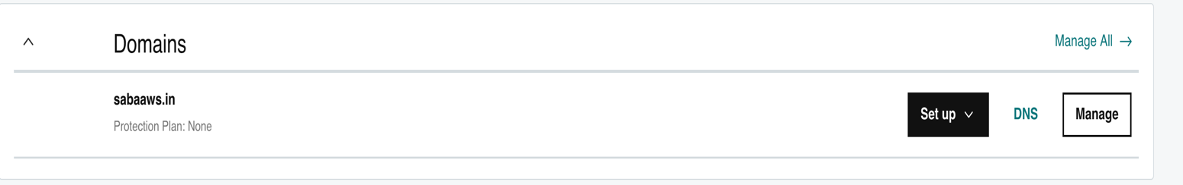



There you will see the DNS section on your domain. Click on the DNS. You will see 2 sections “DNS records” and “Name servers” .

These will first have the DNS records and Default name servers provided by your registrar (in this case Go Daddy).

Now, Create the Hosted zone from AWS Route 53 service for your high level domain.

Once you create the Hosted zone you will have 2 records that are automatically created by the route 53, which are NS records with 4 values and SOA type record with 1 value.



Now, take the NS records values from this hosted zone and add them to the Name servers section on your registrar (Go-daddy) site.

Click on change. You will get to a page like below



You need to choose “Enter my own nameservers (Advanced) at bottom”

Click on add name server and add all the values from your Route53 NS record. You need to add one after one. Once done it will look like below image. Click save. Once saved it will take around 24-48hrs to get reflected.

Once reflected you can’t Manage your DNS records from your domain registrar. All your next DNS records needed to be created and added in the hosted zone you created only.

Note:

1. Don’t create new hosted zone for each record. Use only same hosted zone as you added only these NS records to your Name servers.
2. Make sure on the pricing as it costs,

$0.50 per hosted zone / month for the first 25 hosted zones

$0.10 per hosted zone / month for additional hosted zones.

If you don’t want to go through this process of changing name servers for any reason (Some domain registrars won’t agree for changing name servers) you can create the Hosted zone and records in AWS Route 53 and whatever record you created in Route53 add those records to the DNS records section with same name and value fields.